1. Install JDK 8 from the official Oracle site.

<https://www.oracle.com/technetwork/java/javase/downloads/jdk8-downloads-2133151.html>

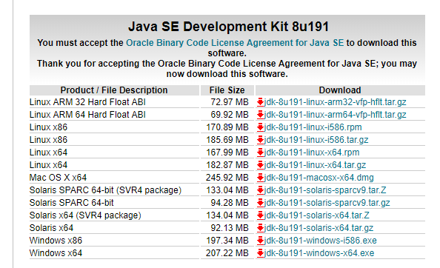

1. Install Java from the installer and add Java to the classpath.

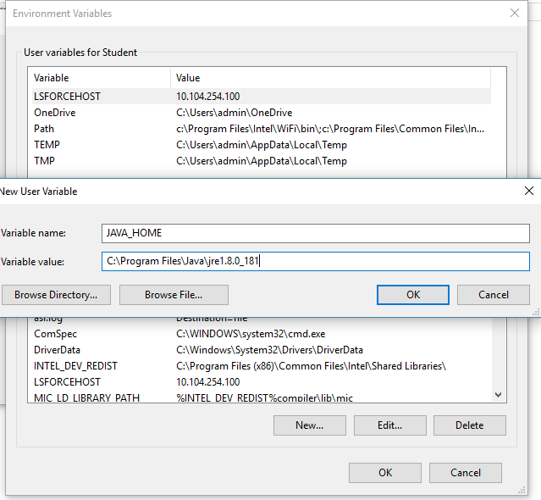

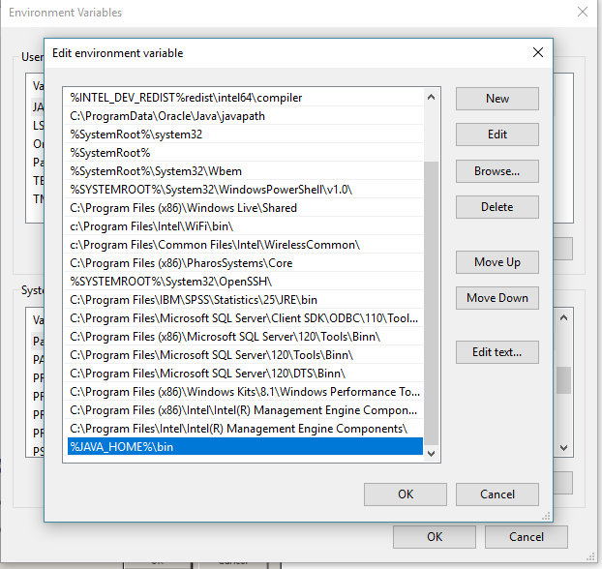

1. Check if java installed successfully and was added to your classpath by opening a command prompt and type in the following command.

java –version

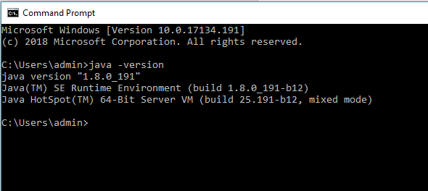

1. Download and install 7-zip from

<http://www.7-zip.org/download.html>

1. Download and extract Zookeeper using 7-zip from

<http://zookeeper.apache.org/releases.html>

1. Download and extract Kafka using 7-zip from

<http://kafka.apache.org/downloads.html>

Version to use: kafka_2.11-1.1.0. [Stable tested version]

**B. Zookeeper Installation**

1. Goto your Zookeeper config directory.

For me its *C:\zookeeper-3.4.12\conf*

2. Rename file “zoo_sample.cfg” to “*zoo.cfg”*

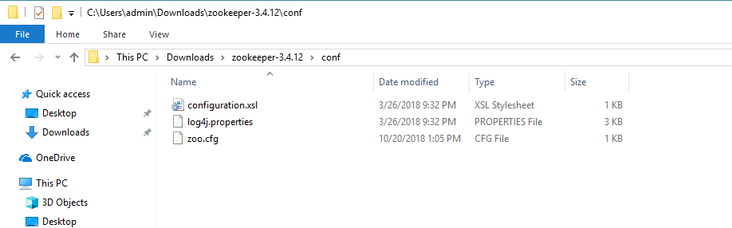

3. Open zoo.cfg in any text editor like notepad but I prefer notepad++.

4. Find & edit dataDir

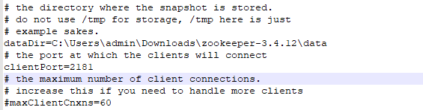

5. Add entry in System Environment Variables as we did for Java

    a. Add in System Variables ZOOKEEPER_HOME= C:\Users\admin\Downloads\zookeeper-3.4.12

b. Edit System Variable named “Path” add %ZOOKEEPER_HOME%\bin

6. Run Zookeeper by opening a new cmd and type zkserver.

7. You will see the command prompt with some details like the image below.

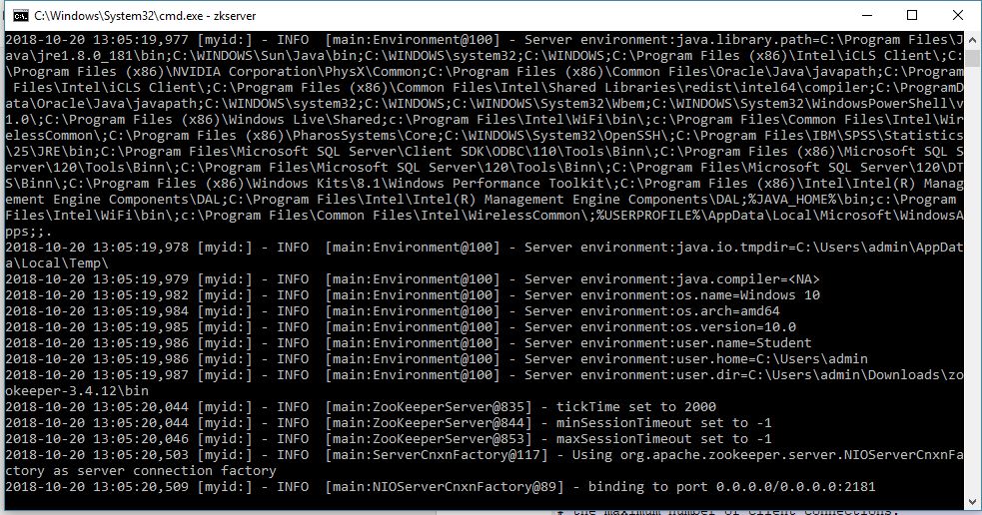

SETTING UP KAFKA:

1. Go to your Kafka config directory. For me its

C:\Users\admin\Downloads\kafka_2.11-2.0.0\config

2. Edit file “server.properties”

3. Find & edit line “log.dirs=/tmp/kafka-logs” to “log.dir= C:\Users\admin\Downloads\kafka_2.11-2.0.0\logs”.

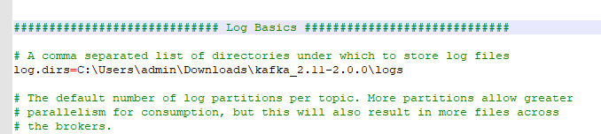

RUNNING KAFKA SERVER:

1. Open a new command prompt inside the folder where you extracted Kafka.

For me its : C:\Users\admin\Downloads\kafka_2.11-2.0.0

1. Now type

.\bin\windows\kafka-server-start.bat .\config\server.properties

and press Enter.

1. You should see something like this:

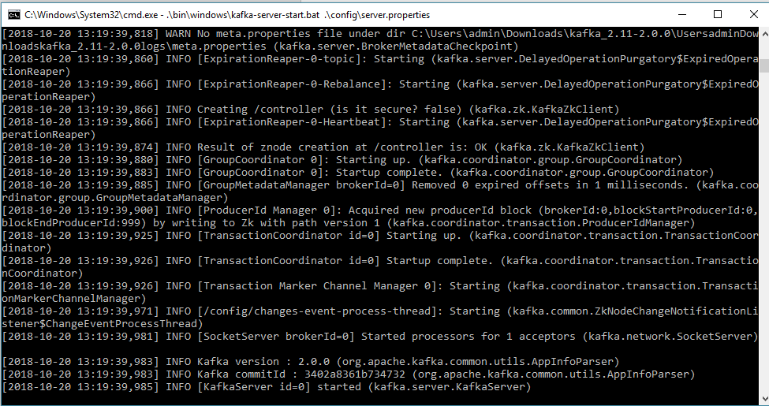

CREATING TOPICS:

1. Open a new command prompt in the location below location:

C:\Users\admin\Downloads\kafka_2.11-2.0.0\bin\windows

1. Type in the following command and press enter.

kafka-topics.bat --create --zookeeper localhost:2181 --replication-factor 1 --partitions 1 --topic test

1. If everything went successful you should see below output in your console.

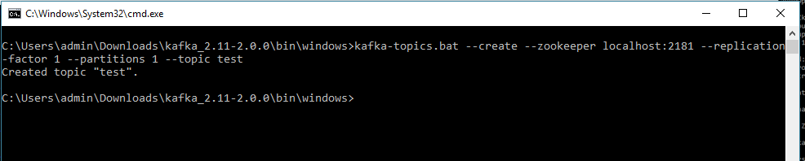

1. Go ahead and create topics “response_topic”, “post_book” which is required to run the demo code.

Download the source code provided by Anurag and the next steps remains the same as provided in the Document shared by Anurag.

1. Run Node Backend
2. Run Kafka Backend
3. Test your code using Postman.

Reference**:**

<https://dzone.com/articles/running-apache-kafka-on-windows-os>